Launch into challenger PTA  April Newsletter  https://challengerpta.ourschoolpages.com/Home  spring is here!  Bingo, Festival of Cultures, Art Walk/Book Fair, and Teacher Appreciation week are being planned this spring and we need YOUR help! These Challenger events for students and staff only happen if we have enough volunteer participation. Please email the PTA at challenger.comets.pta@gmail.com to sign up!  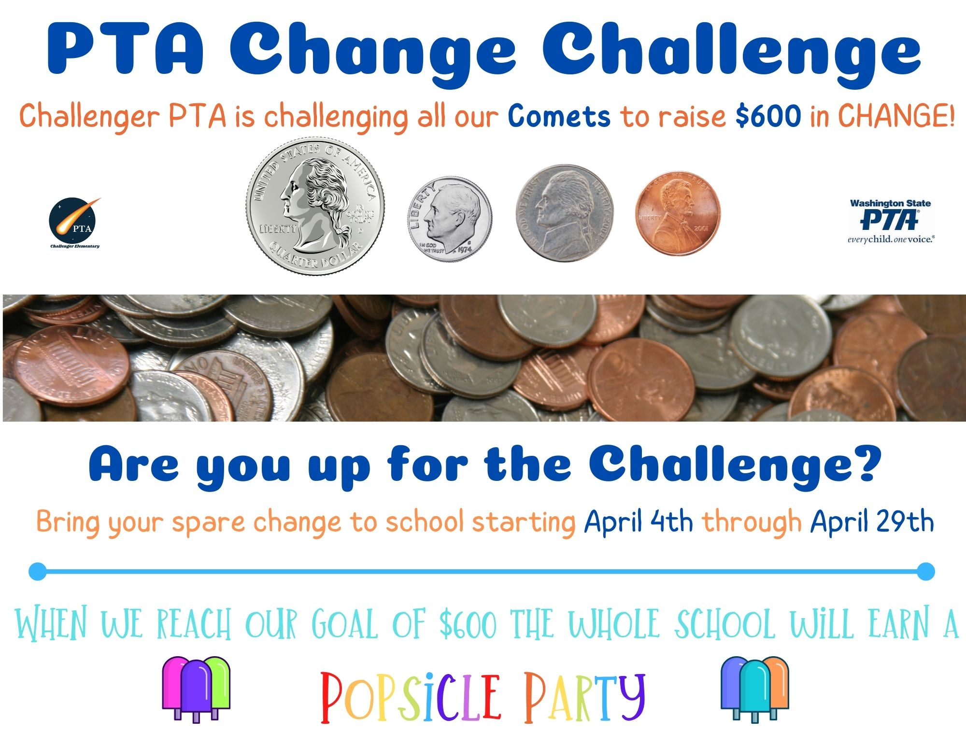  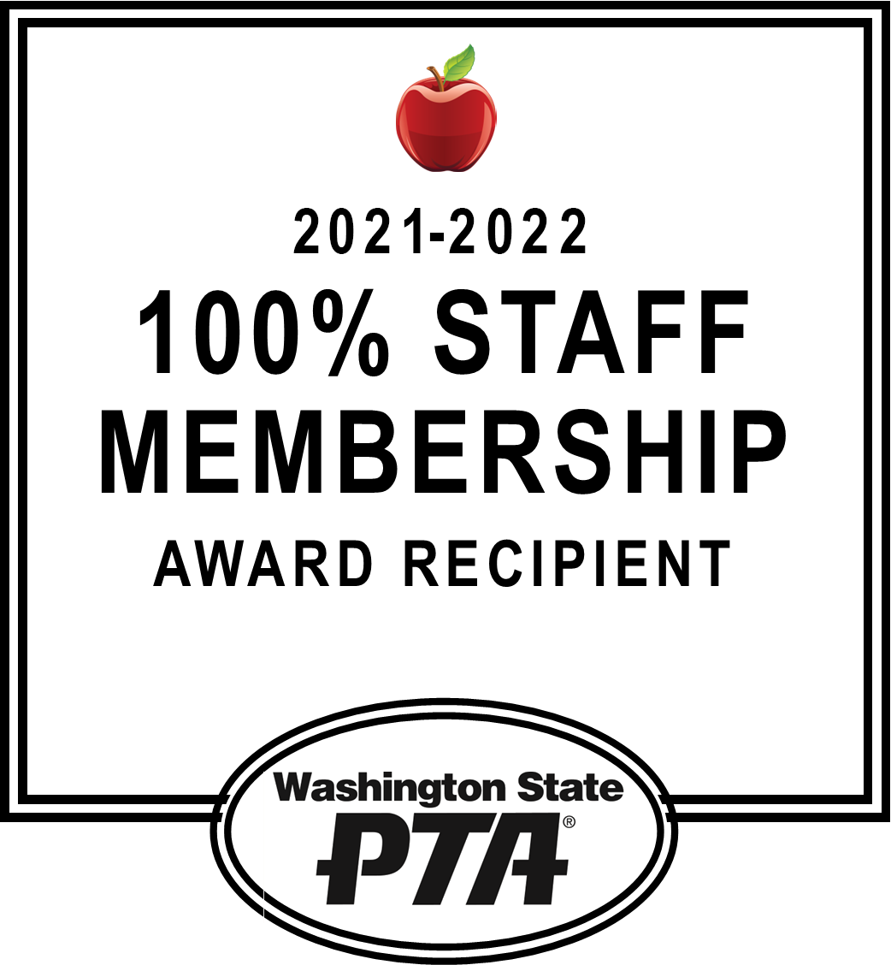  Thank you to everyone who participated in last month’s PTA Book Swap! The extra books were donated to the Issaquah Food & Clothing Bank and a local preschool in need of books! The event was a huge success! | Coming Soon:  Popcorn Friday!  April 1st  challenger Food drive  March 28th- April 8th  Spring Break  April 11th- 15th  spirit day!  April 29th  last General PTA Meeting 2021-2022 school year  May 10th @ 7:00 pm  LIVE WITH PROMISE  Lead our children to a promising future  Involve every parent  Voice for every child  Enrich the community  2021-2022  Challenger Elementary School

